
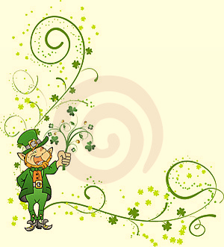
St Patrick’s Day!

Next Tuesday is March the 17th – St Patrick’s Day – so we thought
we’d have a night to celebrate everything Irish and green! Come
along dressed for the day – Green!– and you can let your
imagination run wild – perhaps some leprechauns or the like?

BE THERE… or be green with envy!

Akela – Rosanna Cubs

